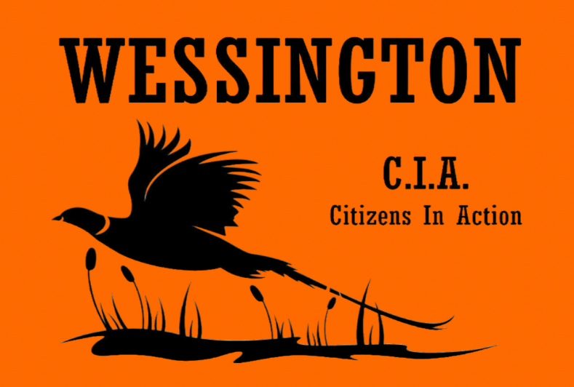

Wessington Citizens In Action Scholarship
Wessington Citizens In Action is an organization dedicated to enhancing the community through various initiatives, including advocating for community enhancements, fostering youth engagement, and facilitating fundraising endeavors for both school and community initiatives. Annually, we organize pheasant races and a banquet to raise funds for the conservation of the pheasant population, as well as to support our community and scholarship initiatives.

Last Name: ___________________ First Name: _____________________ DOB: __________
Address: _____________________ City: _________________ State: ____ Zip Code: _______
Phone: ______________________ E-mail: _________________________________________
High School currently attending: _________________________________________________
Trade School/College attending in fall 2024: ______________________________________
Address: _____________________ City: _________________ State: ____ Zip Code: _______
Specialty/Major planning to pursue: _____________________________________________

A scholarship of $1,000 will be presented to a 2024 Senior student who submits the most compelling short essay discussing their engagement in their community and expressing the significance of Wessington in their lives.
Kindly email a brief essay along with your application to cloverherdman@icloud.com by April 17, 2024. The scholarship recipient will be announced during the annual scholarship presentation hosted at the school.

